Handout no. 1

|  |  |
| --- | --- |
| **Name** | Faizan, M Asad, Asad ul Rehman |
| **Reg. No** | 2019-EE-381, 383, 389 |
| **Marks/Grade** |  |

**EXPERIMENT # 1**

**Single Phase Voltage transformers**

**Objective:**

At the end of this lab session students will be able to

* Use De Lorenzo power system Protection kits.
* Implement “Voltage transformer” by using De Lorenzo power system Protection kits.
* Voltage Transformer operation in an electrical subsystem
* Determining the transformation ratio of a voltage transformer for various primary voltages and investigating the influence of load on transformation ratio.
* To explain the term ratio error and accuracy class.

**Introduction:**

Utilities are responsible for the generation, transmission and distribution of electricity to customers. Part of this responsibility is ensuring a safe but yet reliable power supply to customers. For the purpose of safety and protecting the transmission and distribution network from faults, utilities worldwide have sophisticated protective equipment. Collectively, these are known as secondary equipment and include the current transformers (CT), potential transformer (PT) and protective relays.

**Apparatus:**

* 1DL 1055TT Experimentation Transformer
* 1DL 2108T11 VT LOAD
* 1DL 2109T23 Single Phase Voltage Transformer
* 2 DL 2109T3PV Moving iron voltmeter

**Voltage Transformers:**

Potential transformers are parallel connected, and are designed to read the voltage phase and ratio relationship during metering. One can connect the primary terminals on a potential transformer in two configurations. These configurations include line to line, or line to neutral.

There are three different types of potential transformers, including an electromagnetic type, a capacitor, and an optical. The optical potential transformer s used in conjunction with electrical properties of optical equipment. The capacitor type is used for higher voltages, and the electromagnetic potential transformer is of the wire-round type. In potential transformers, burden and accuracy are combined, as they are dependent on each other. Most potential transformers have smaller cores and capacities when compared to power transformers.

When using a potential transformer, certain quantities need to be scaled prior to use. These include power, voltage, demand and energy. The use of transformers and potential transformers will require some basic electrical wiring knowledge, as well as experience with voltage.

**VT Basic Wiring Diagram:**

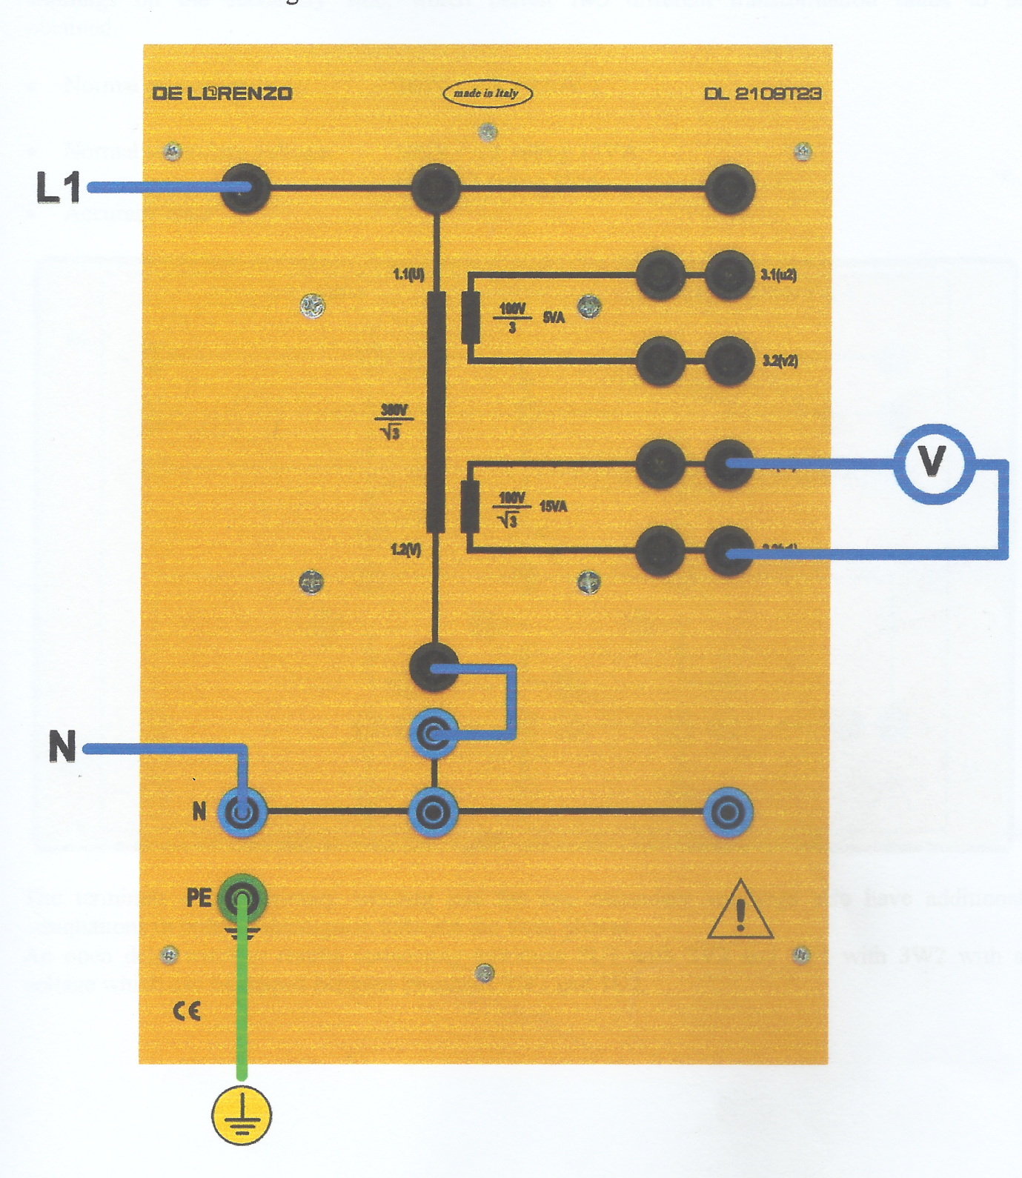

Figure 1 : VT internal wiring Diagram

***Circuit construction:*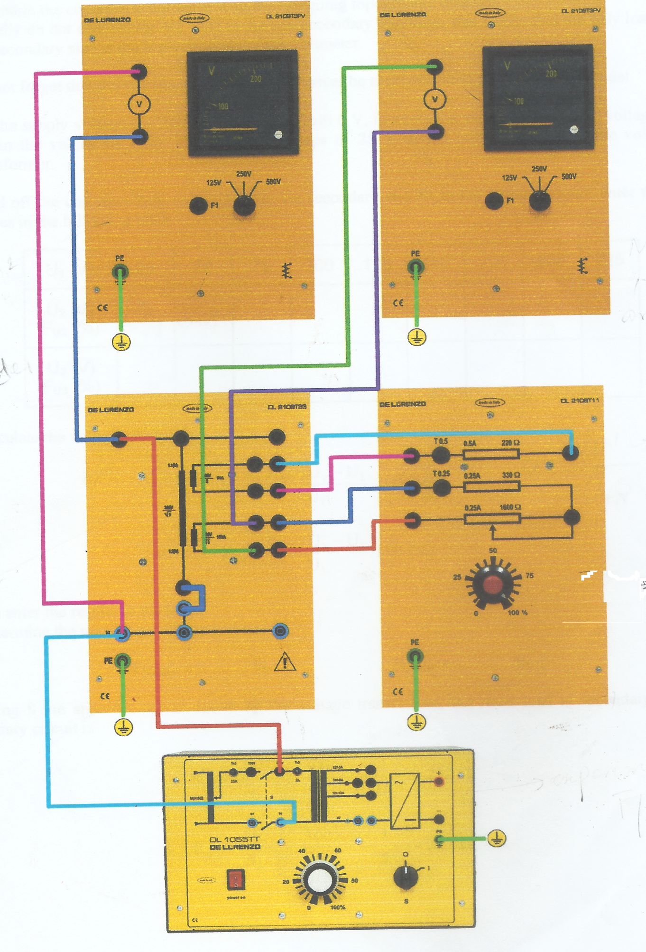**Figure 2 Voltage T/F circuit

**Procedure:**

* Connect circuit as shown in Fig 2.
* Initially do not connect the VT load to secondary windings and only load connected is high resistance of voltmeter.
* Connect Voltage transformer with only ammeter resistance no other resistance is required
* Set power supply voltage 0÷250v and increase value of primary voltage measure secondary and tertiary voltages.

**Transformation ratio1:1**

**Specified Primary Voltage = $U1N=$ 380 / (3)1/3**

**Specified secondary Voltage = $U2N$ = 100/3**

**Specified secondary Voltage = $U3N$ = 100/(3)1/3**

**At no load Condition:**

**Table 1:**

|  |  |  |  |  |  |
| --- | --- | --- | --- | --- | --- |
| **U1(V)** | **14.14** | **28.22** | **42** | **56.2** | **70.9** |
| **U2(V)** | 2.14 | 4.14 | 6.37 | 8.53 | 10.78 |
| **U3(V)** | 3.7 | 7.4 | 11.1 | 14.8 | 18.8 |
| **Fi2(%)** | 0.415 | 3.46 | 0.20 | 0.129 | 0.045 |
| **Fi3(%)** | 0.565 | 0.354 | 0.42 | 0.07 | 0.76 |

**Calculate Voltage error**:

**FU2 = (KN2.U2-U1/U1)*100%**

**FU3 = (KN3.U3-U1/U1)*100%**

**1-Determine maximum Voltage error:**

**FU2 =** 3.46 **%**

**FU3 =** 0.565% **%**

**At loaded Condition:**

**Table 2:**

|  |  |  |  |  |  |
| --- | --- | --- | --- | --- | --- |
| **U1(V)** | **14** | **28.43** | **42.2** | **56.8** | **70** |
| **U2(V)** | 2.1 | 4.28 | 6.37 | 8.55 | 10.52 |
| **U3(V)** | 3.7 | 7.4 | 11.1 | 14.9 | 18.3 |
| **Fi2(%)** | 1.3 | 0.94 | 1.14 | 0.95 | 1.11 |
| **Fi3(%)** | 0.42 | 1.09 | 0.518 | 0.316 | 0.659 |

**Determine maximum Voltage error:**

**FU2 =** 1.14 **%**

**FU3 =** 1.09 **%**

**At no load Condition:**

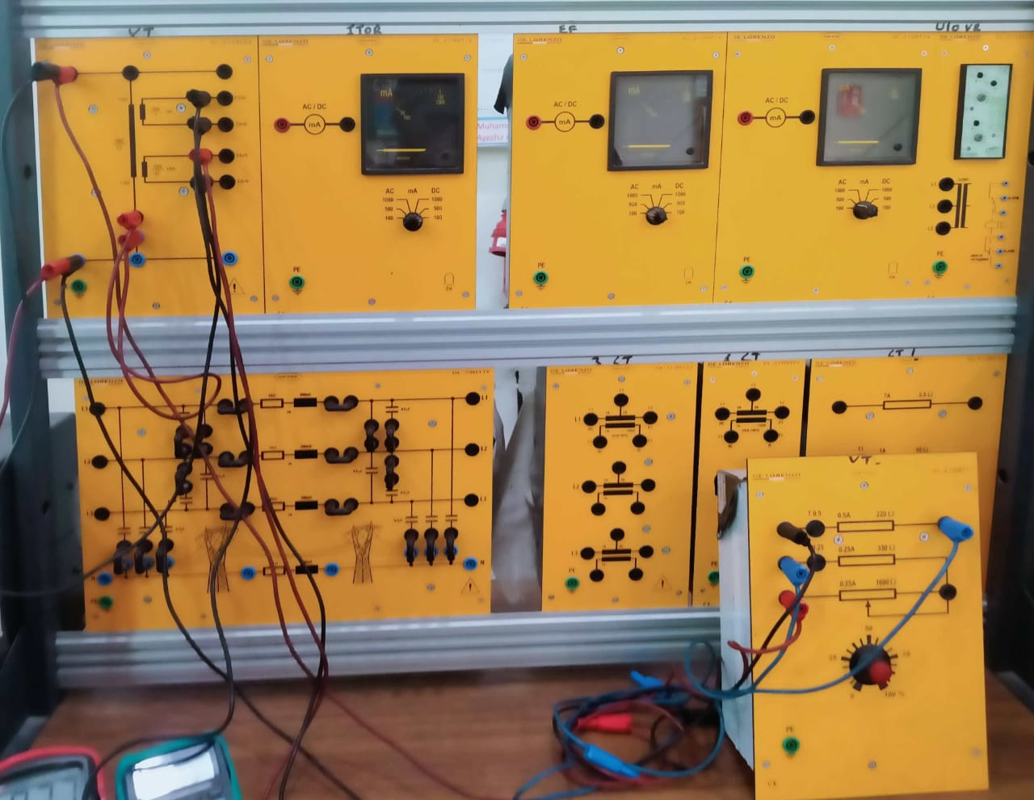

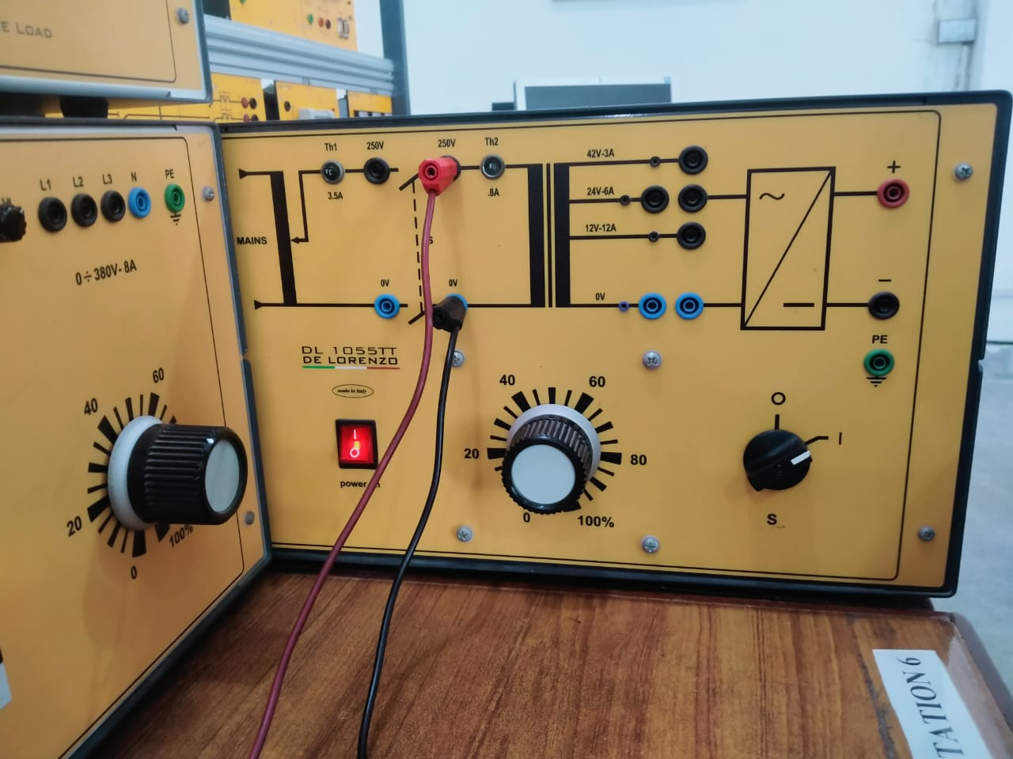

**Meter Readings:**

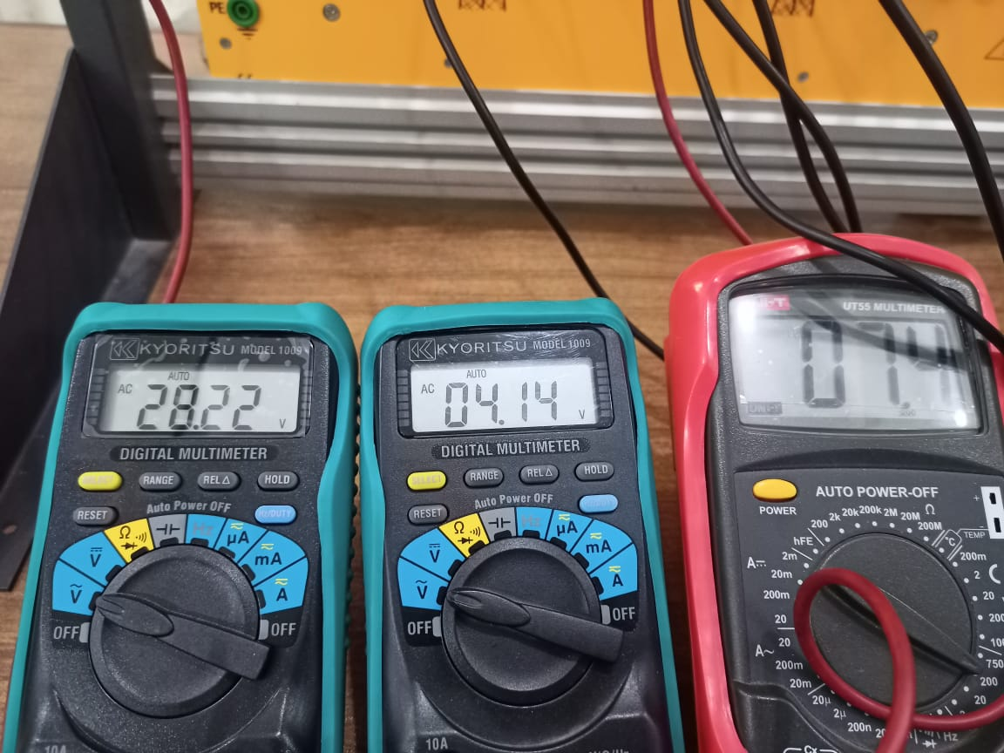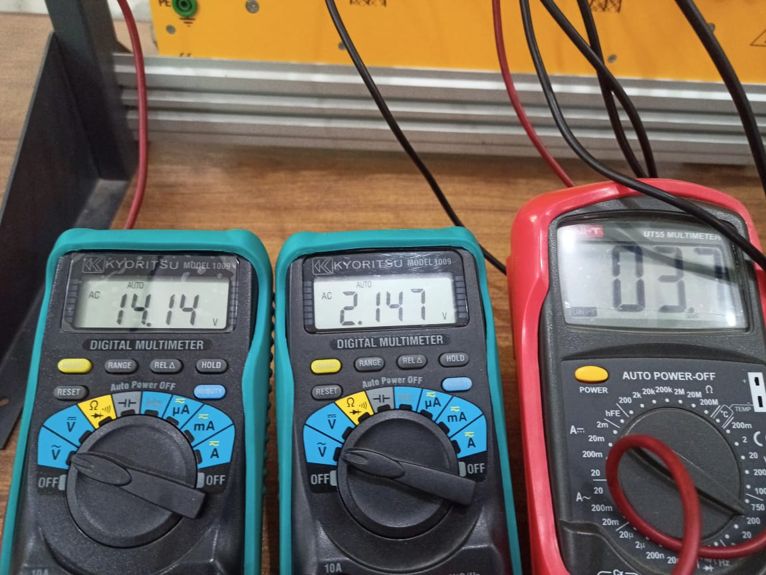

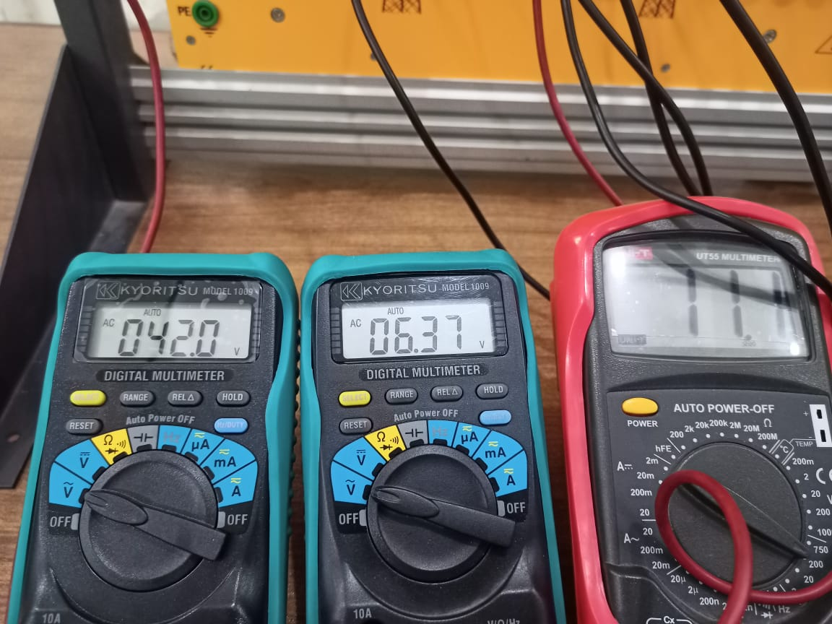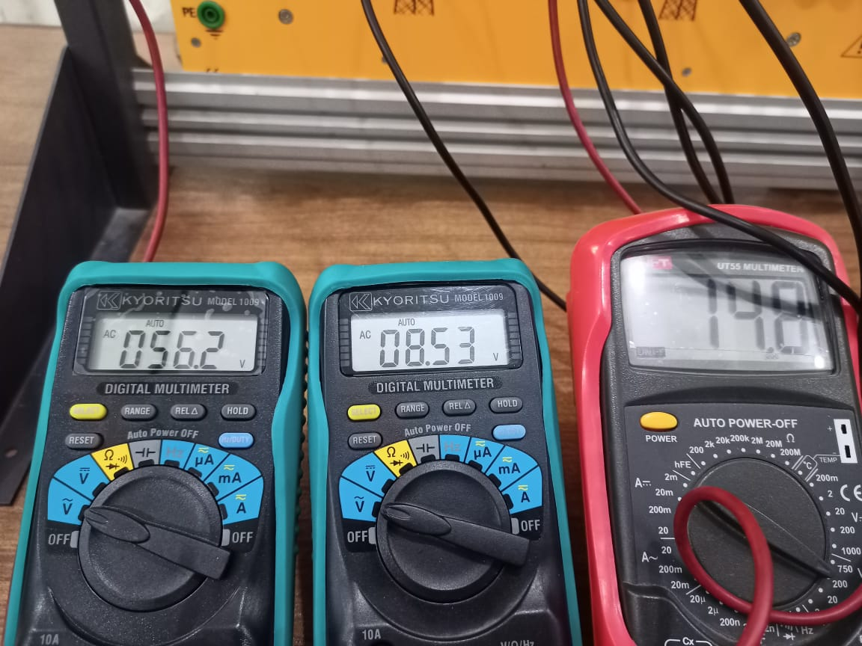

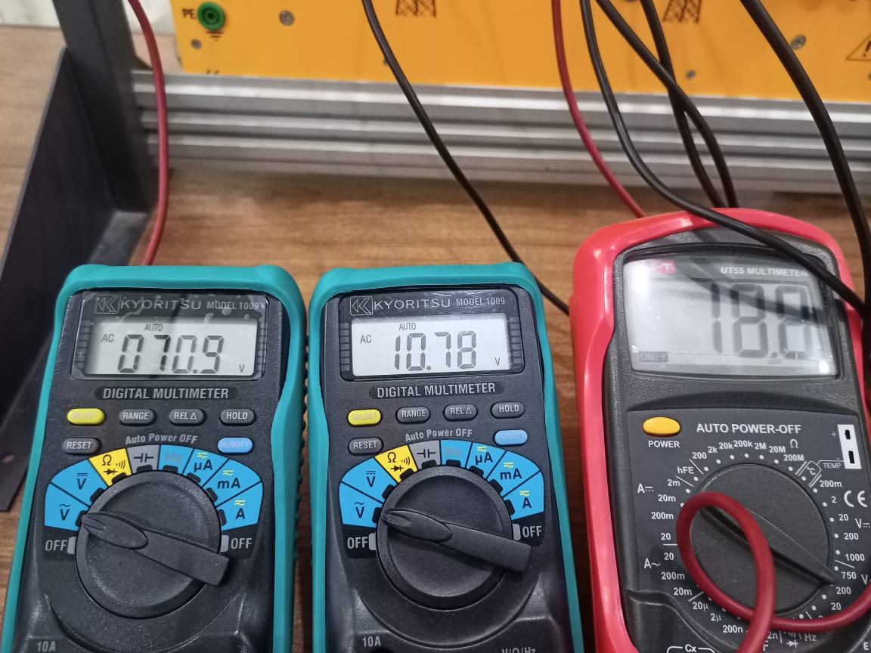

**At loaded Condition:**

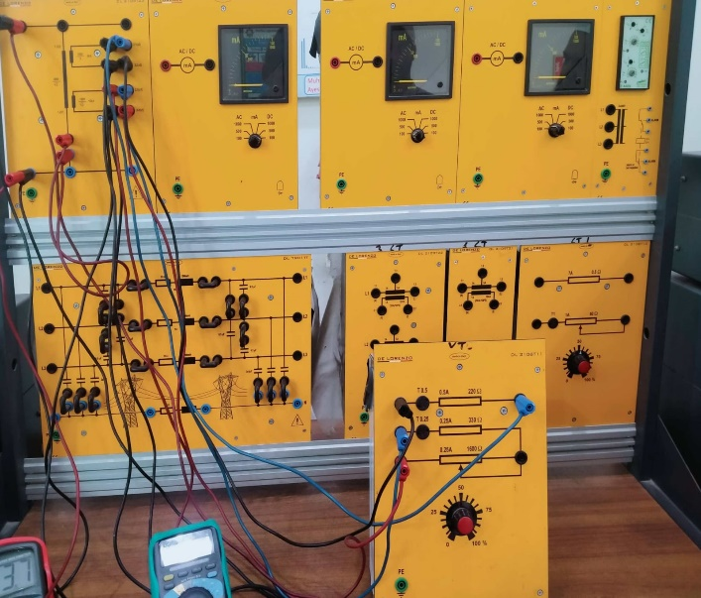

**Meter Readings:**

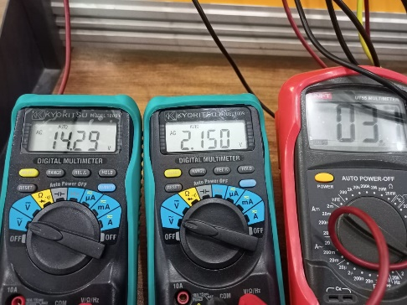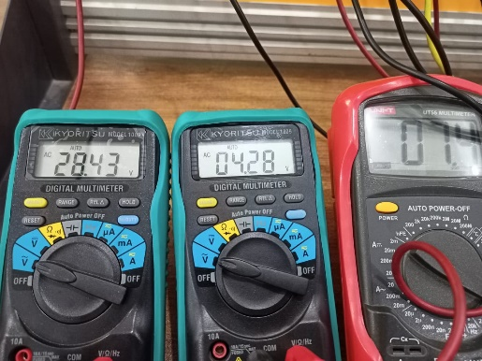

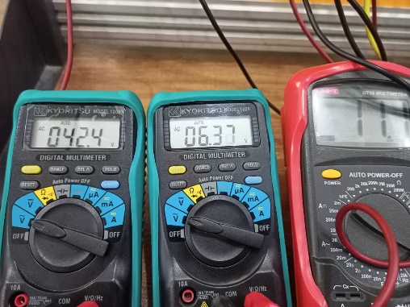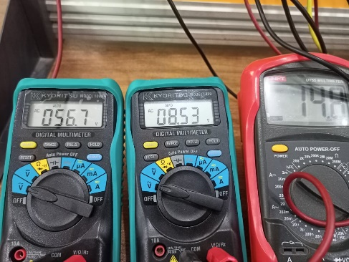

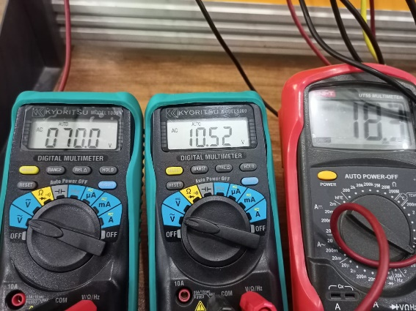

**Calculations:**

**At Load:**

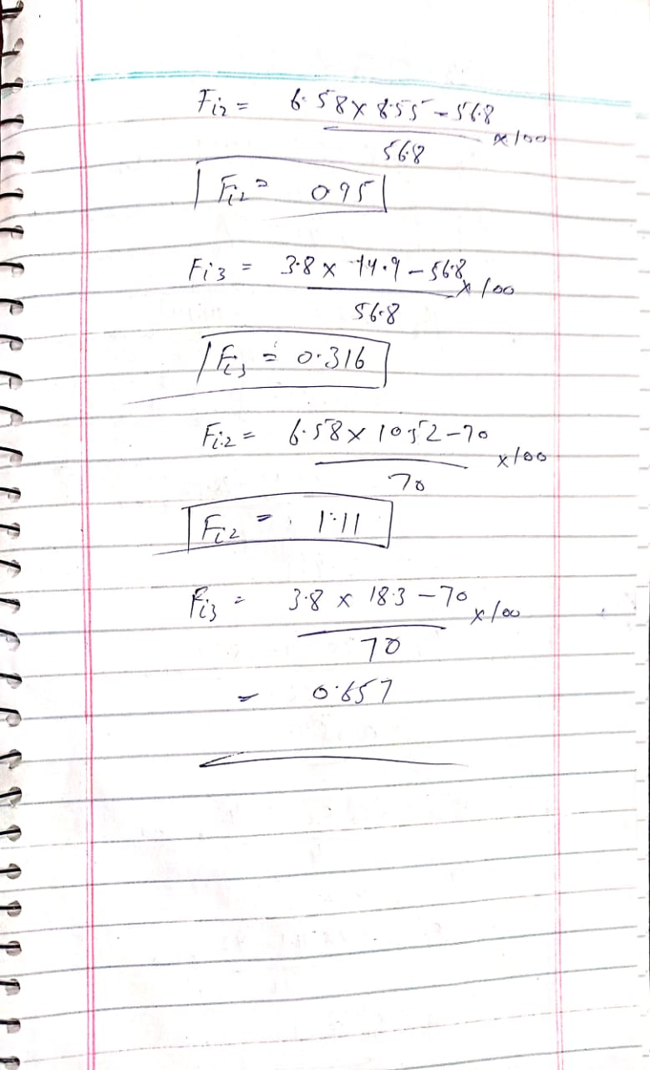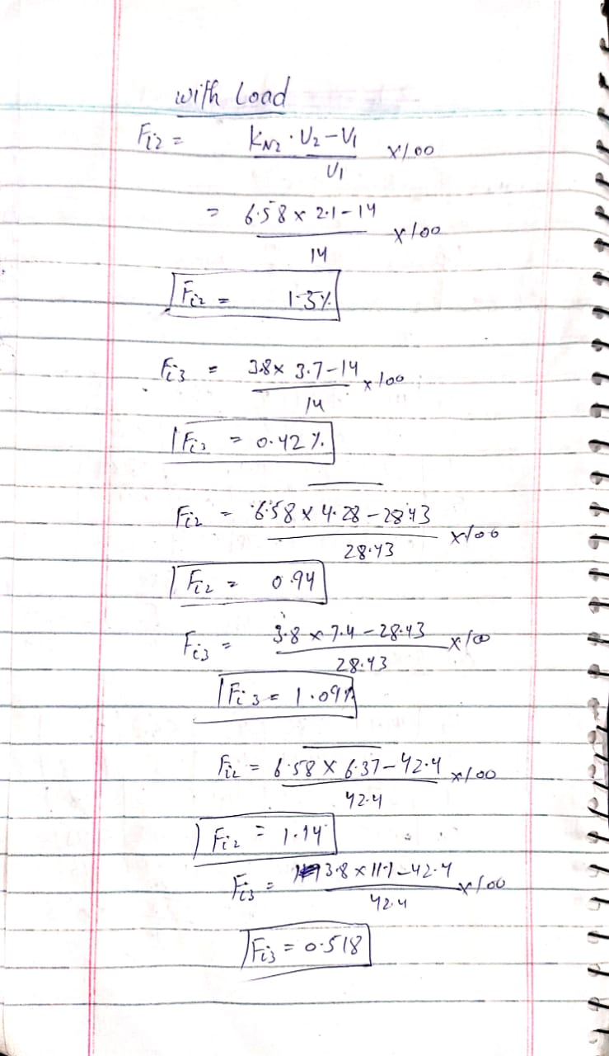

**At no-Load:**

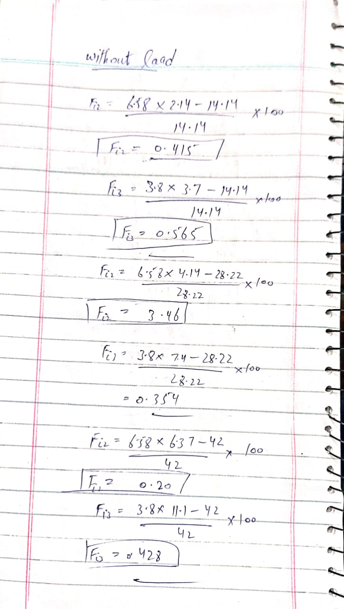

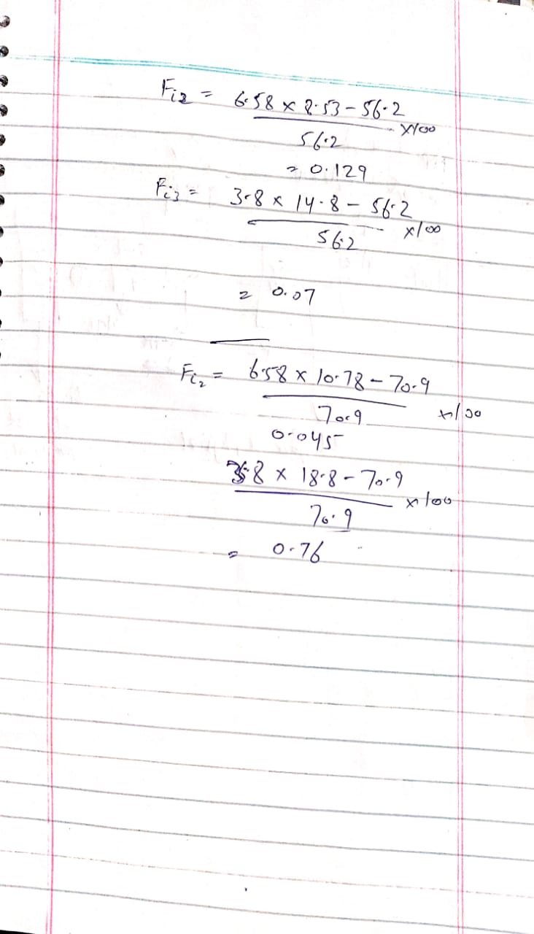

**Observation:**

In this lab, we learn about the operation of single-phase voltage transformer operation in power substation by using De Lorenzo power system protection kit. We calculated the ratio error of potential transformer at loaded and no-load condition. We observed that as the primary voltage reaches to its source value the percentage error sharply decreases. It shows that at the rated condition the ratio error is minimum and vice versa.